# CSS 422 Hardware and Computer Organization Sequential Circuits Lab: Random Number Generation Instructor Rob Nash

Notes: Pick a group you haven’t yet worked with and attack this part of the lab. Have one person submit this to canvas or in-person when complete.

**Group names:**

Boyang Zhao

Thuan Tran

Aaron Vega

JD Mauthe

## A Random Number Generator

Consider the circuit shown, which is made up of 4 D flip-flops and 2 XOR gates. Only the ~RESET (active low) line may be asserted, so there is no SET line in this circuit. Build the circuit in Logisim and answer the following questions.

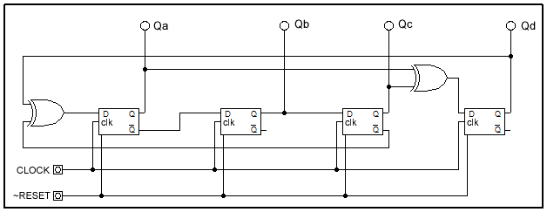

1. What is the state of the outputs (Qa, Qb, Qc, and Qd) after a reset is asserted?

The state of the outputs after a reset is asserted are:

Qa = 0

Qb = 0

Qc = 0

Qd = 0

1. Bring ~RESET high so it is disabled. Fill in the table below by tracking the outputs for 18 clock cycles and convert the bits to hex.

|  |  |  |
| --- | --- | --- |
| Clock Tick | QaQbQcQd | Hex |
| 0 | 0000 | 0x0 |
| 1 | 1100 | 0xC |
| 2 | 1011 | 0xB |
| 3 | 1000 | 0x8 |
| 4 | 1001 | 0x9 |
| 5 | 0001 | 0x1 |
| 6 | 0100 | 0x4 |
| 7 | 1110 | 0xE |
| 8 | 0010 | 0x2 |
| 9 | 0101 | 0x5 |
| 10 | 0110 | 0x6 |
| 11 | 0111 | 0x7 |
| 12 | 1111 | 0xF |
| 13 | 1010 | 0xA |
| 14 | 0000 | 0x0 |
| 15 | 1100 | 0xC |
| 16 | 1011 | 0xB |
| 17 | 1000 | 0x8 |

1. How many pulses occur before the outputs loop around to the same pattern again?

14 pulses.

1. How would you extend this concept of a “random number” generator to 5-bits? In this case, how many distinct numbers can you generate?

The number of possible numbers seems to be roughly 2^n with n as the number of bits. With this, the number of distinct numbers for 5 bits might be 30.

1. Build the 5-bit generator by adding one D flip-flop and one XOR gate to your previous design. Log the results and submit both circuit files.

|  |  |
| --- | --- |
| Pulse | Output |
| 0 | 00000 |
| 1 | 11001 |
| 2 | 00110 |
| 3 | 01010 |
| 4 | 01101 |
| 5 | 01110 |
| 6 | 01111 |
| 7 | 11111 |
| 8 | 10101 |
| 9 | 00001 |
| 10 | 01001 |
| 11 | 01100 |
| 12 | 11110 |
| 13 | 00101 |
| 14 | 01011 |
| 15 | 11101 |
| 16 | 00100 |
| 17 | 11011 |
| 18 | 10111 |
| 19 | 10000 |
| 20 | 10011 |
| 21 | 10010 |
| 22 | 00010 |
| 23 | 01000 |
| 24 | 11100 |
| 25 | 10100 |
| 26 | 10001 |
| 27 | 00011 |
| 28 | 11000 |
| 29 | 10110 |
| 30 | 00000 |